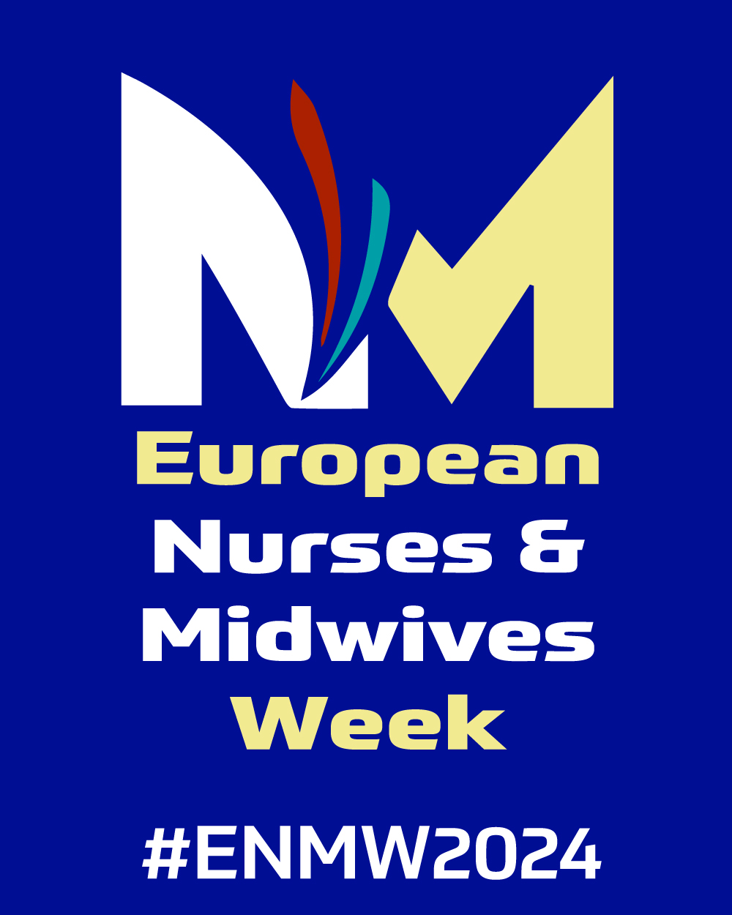 | CALL FOR CASE STUDIES  Successful stories and lessons learned of nurse and midwives in primary health care
European Forum of Nursing and Midwifery Associations (EFNNMA) invites all nurses and midwives of WHO European Region to submit case studies highlighting their crucial in delivering primary health care services.
We are particularly interested in case studies that demonstrate the challenges, innovations, and impact of nursing and midwifery practice in various settings, including integrated care approach, continuity of care, and role respect migrant and marginalized populations.
Topics of interest include, but are not limited to:
- Nurse-led and midwife-led primary health care interventions
- Integrated care and care continuity
- Patient experience and role of nurses and midwives
- Experience of joint activities on health and social care services,
- Digitalization development in primary health care
- Interprofessional collaboration and teamwork in primary health care
- Community engagement and empowerment strategies
- Innovative approaches to health education and promotion
- Addressing social determinants of health in primary care settings
- Challenges and solutions in resource-limited environments
- Impact of nursing and midwifery interventions on health outcomes
- Policy and advocacy efforts to strengthen primary health care systems

What kind of case studies are we looking for?
We are looking for short, real-life stories about an initiative, project or advocacy campaign that showcase some of the great work that is already being implemented in primary health care at different levels to help communities and societies. Sharing experiences of unsuccessful projects and lessons learned is also welcome. Case studies should be well-structured, evidence-based, and provide clear implications for nursing and midwifery practice, education, research, or policy.

What should primary case study look like?

Be visual: share pictures, video or illustrative elements if possible;

Be different: show the impact of nurses and midwives and the role different stakeholders in driving positive change

Be special: show the people behind the initiative, and share at least 1 quote or personal perspective, ideally from a person directly involved in the project or from an expert in the field;

Be short and concise: limit your case to 1 page (600 words or less), if possible

CALL FOR CASE STUDIES

Successful stories and lessons learned of nurse and midwives in primary health care
CASE STUDY Title

Organization/Group leading the case study, contact details & website:

In which region(s) is this case study implemented? Please list specific country/countries if possible.

Please provide a summary in 500/800 words
Example of questions that a primary care case study should address.
- (The questions are meant to help you structure your case study and help ensure all relevant information is present, but are not mandatory

- What is this case study focused on?

- What are the key stakeholders and sectors involved?

- What is the timeframe of this case study? Is it ongoing or finalized?

- What are the key lessons learned that could be used by other key players in this field (in a local, national or regional context)?

- Is this case study replicable in other countries/geographical settings?

- Which quote can best illustrate the case study? Who is the author, and what is the author's role in this project?

Result

Outline the results of the action taken.

Next Steps

Summarise any next steps you intend to take.
Any other information
- Other additional information you would like to provide regarding the case study:

- Are there any additional internet or social media resources related to this case study that you would like to share?

