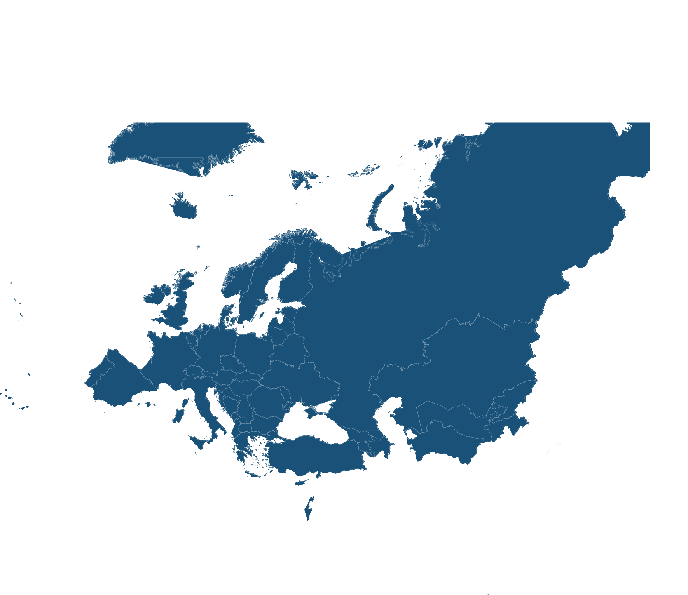

ADD LOGO

NATIONAL ASSOCIATION/UNIVERSITY

**(KIND OF EVENT** (i.e. conference, webinar)

**]**

**[EVENt title**

**over two lines]**

X May 2023

[XX:XX – XX:XX] [am/pm] CET

Please register at [www.xxxxxx. ] and/or contact [mail address]

**PROGRAMME**

**[Insert details]**

*Including institutions, speakers, time, moderator etc.*